# CS 255 System Design Document Template

This template lays out all the different sections that you need to complete for Project Two. Each section has guidance to prompt your thinking. You will need to continually reference the interview transcript as you work to make sure that you are addressing your client’s needs. There is no required length for the final document. Instead the goal is to complete each section based on what your client’s needs are. Remove this note when you are finished, and replace all bracketed text with the relevant information.

## UML Diagrams

### UML Use Case Diagram

### UML Activity Diagrams

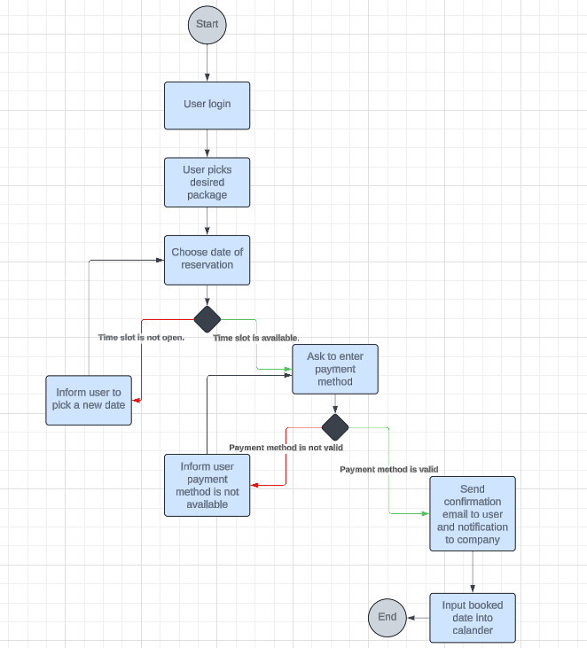

### UML Sequence Diagram

### UML Class Diagram

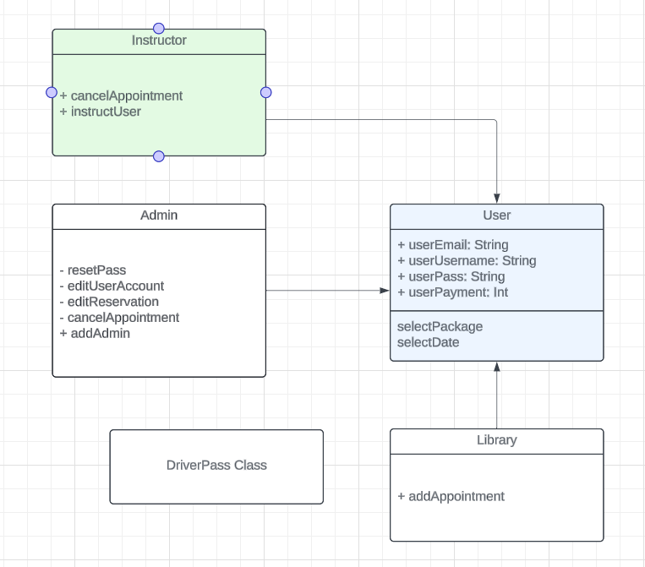

## Technical Requirements

*Here are some technical requirements from the system created:*

* Navigable user interface (web-based)
* User credentials and levels to authorization
* Different chains of command
* Date selection availability for everybody to view
* Payment method validation
* Database or library for booked appointments
* User/student account creation ability
* User authentication – this comes with ability for admin to reset passwords or delete accounts
* Give choice for anybody to edit reservation
* Security software